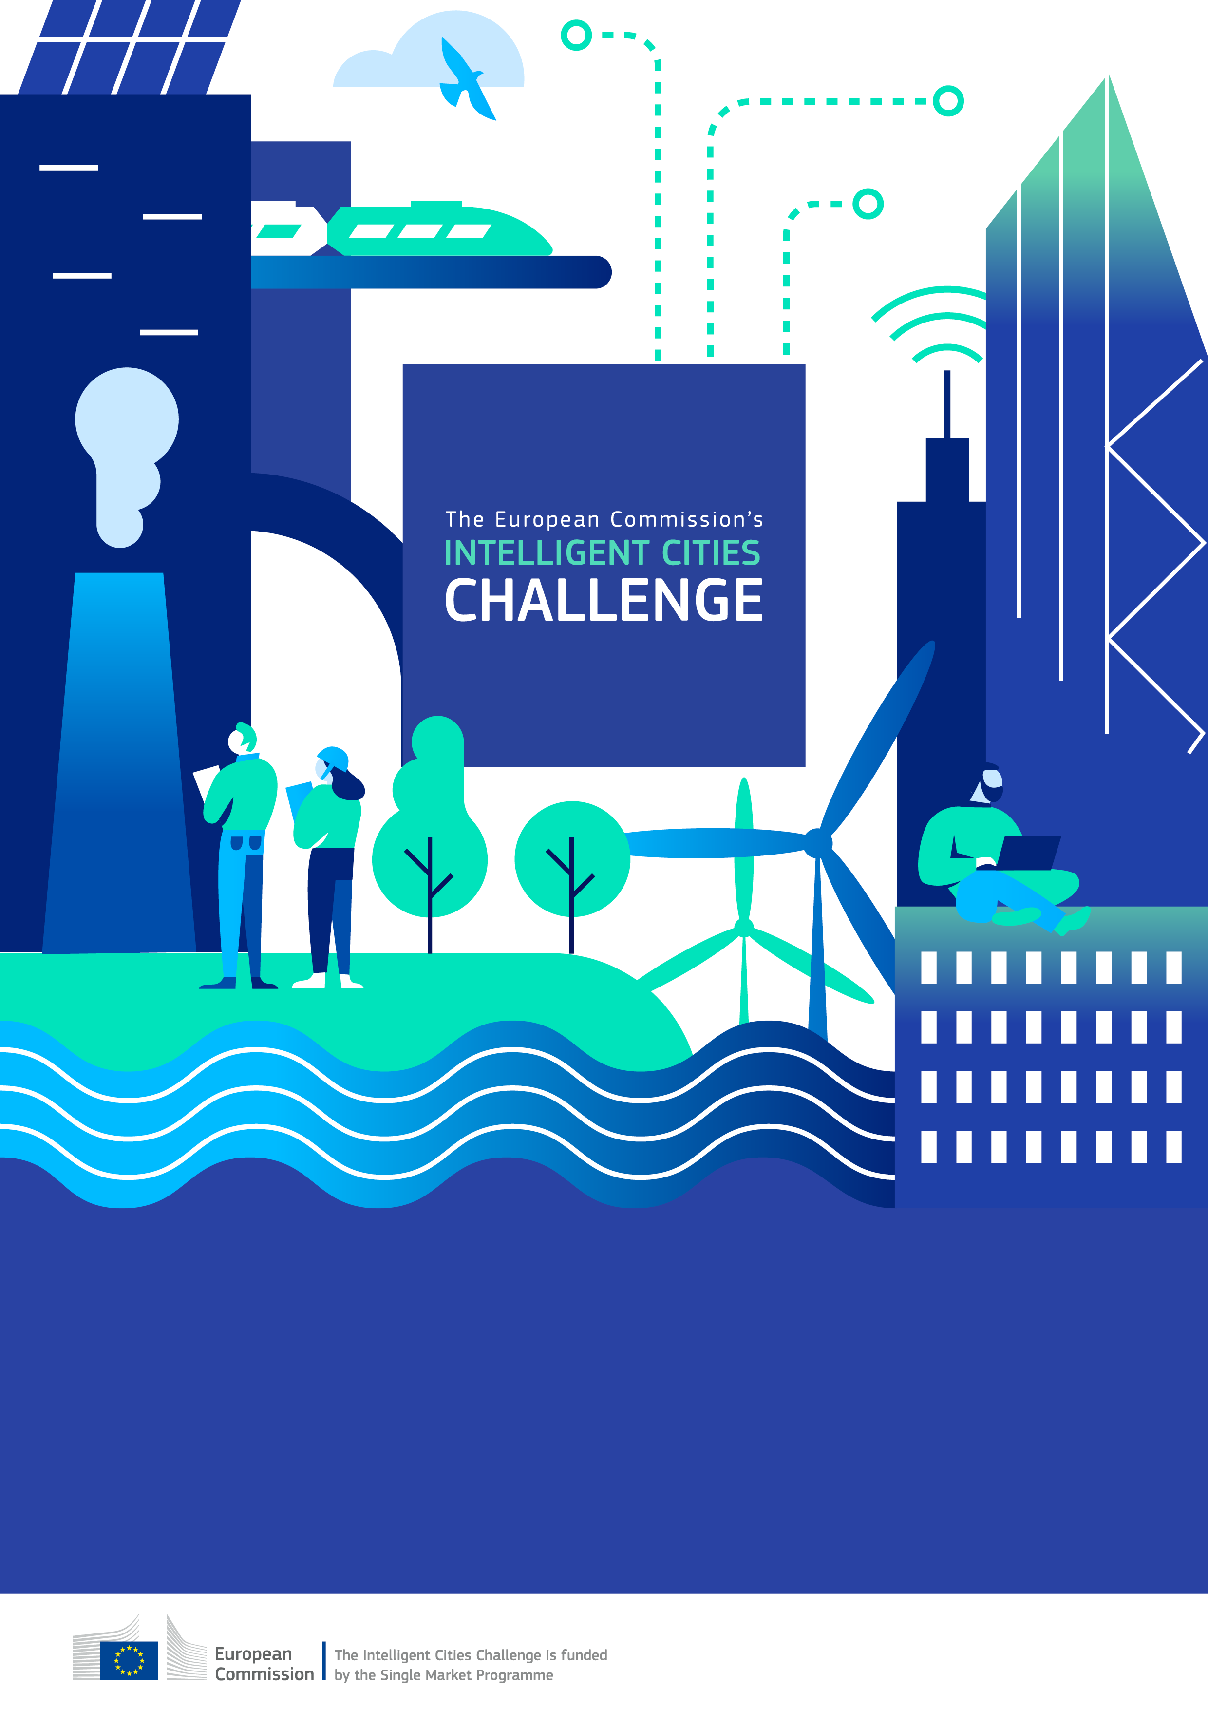
Local Green Deal – Green Public Bus Transportation Solutions in Szombathely
- Municipality of Szombathely City with County Rights
- Blaguss Agora Hungary Ltd.

LOCAL GREEN DEAL in Szombathely

PREMISE
The Municipality of Szombathely City with County Rights (hereafter Szombathely) uses Local Green Deals (LGDs) as a strategic governance approach to accelerate sustainability action at the local level, in line with the goals of the European Green Deal.
Szombathely seeks to sign individual LGDs to implement its sustainability strategies, that define the framework for the local green deal actions, namely:
the Sustainable Urban Mobility Plan of Szombathely (SUMP);
its complex economic and urban development strategy, the Szombathely2030;
the Sustainable Energy and Climate Action Plan of Szombathely (SECAP);
and partly its own Hydrogen Strategy, to reach its stated goals.
The present LGD is designed with the following role of Szombathely and will define each signatories’ contributions accordingly in the subsequent sections.
- City as contributor (e.g. City-to-Business)
i.e. The local government is an active contributor to measures committed to by one or more businesses, NGOs, municipal companies, or business intermediaries, like Chamber of Commerce, business associations, etc..
- City as facilitator (e.g. Business-to-Business; Business-to-NGO; etc.)
i.e. the local government will facilitate actions agreed between at least two businesses
- City as broker (City-to-City)
i.e. An internal agreement between different local government units or organisations, such as the administration, the city council, or a municipal company.

Local Green Deal between the Blaguss Agora Hungary Ltd. and Local Government of Szombathely City

- Scope of the Local Green Deal
This Local Green Deal focuses on the Transport & Mobility sector. It supports the realization of Szombathely's four above mentioned complementary strategies by promoting public transportation over individual mobility, thereby reducing CO2 emissions. The ambition is to enhance environmental quality and increase public transport usage, contributing to a greener urban environment. Benefits for partners include increased competitiveness in sustainable transport solutions and alignment with broader sustainability goals.

This LGD aims to help accelerate the implementation of the above-mentioned sustainability strategies of Szombathely, with the ambition for impact regarding the reduction in CO2 emissions by 15% within the city by 2030 and the achievement of a 20% increase in public transport usage by 2028 compared to 2022 levels. It will be a huge benefit for both partners, because on the one hand it helps to achieve the local government’s CO2 reduction goals, while on the other hand it boosts the implementation of the goals of Blaguss in connection with promoting public transport in Szombathely and increasing its usage.

- Partners to the Local Green Deal

Blaguss Agora Hungary Ltd., a member of the family-owned BLAGUSS group established in 1929, has evolved significantly since its inception in the late 1920s. Starting as a transport service for producers in Burgenland to Austrian markets, the company has expanded to become an important player in Hungary's transportation sector. With a commitment to offering the latest in fleet technology and customer service, Blaguss Agora Hungary has a modern bus depot and one of Hungary's youngest fleets, with nearly 85 buses. The company, headquartered in Sopron, emphasises safety, comfort, and environmental responsibility, reflected in their recent initiatives like the introduction of quality and environmental management systems. In 2022, they marked a milestone by securing the responsibility for Szombathely city’s public transportation, maintaining their high standard of service, with a fleet on brand new EURO6 Mercedes buses.

Partner 1: Blaguss Agora Hungary Ltd.
- Organization type:
☒ Private company
☐ Publicly owned company
☐ NGO, non-profit
☐ Financial institution
☐ Academic institution
☐ Other (please specify)_________________________

- Sustainability goals in the relevant impact area – One of the primary challenges in Szombathely's urban transportation landscape is the relatively low usage of public transportation among its population. Despite the availability of the public transport system, a significant portion of the city's residents still prefer other means of travel, especially personal transport. Nevertheless, the trend is positive in this regard,
which not only contributes to less traffic congestion and environmental pollution but also promotes sustainable and eco-friendly transit options. Quantifying the impact of the increased public transportation services is crucial for the city's policy making, and to achieving the broader goals of reducing carbon emissions, improving air quality, and fostering a more sustainable urban environment. Blaguss Agora Hungary Ltd. reduced CO2 emissions through the introduction of a new fleet of EURO6 buses, would like to become more environmental-friendly by introducing firstly an e-bus pilot project in Szombathely, after that even more electric buses, and aims to implement more digitalized solutions to enhance user experience.

- Partner relevance to LGD implementation – Blaguss Agora Hungary Ltd.’s role is crucial for providing the public transport services needed to achieve Szombathely's mobility goals. Blaguss and the Municipality of Szombathely City with County Rights together are determined to focus on quantifying the impact of an increasing number of local citizens using public transportation. This initiative aims to gather and analyse data on public transport usage, providing valuable insights into current trends and potential areas for improvement. By understanding the specific patterns and preferences of the city's residents, this partnership seeks to develop targeted strategies to encourage more people to choose public transportation over personal vehicles. The outcomes of this partnership are expected to inform future urban planning and policy decisions, ensuring that public transportation remains a viable, efficient, and preferred choice for the residents of Szombathely.

- Specific measures and monitoring

The Municipality of Szombathely City with County Rights commits to:
Scope/sector | Transport & Mobility
Action | Greening and promoting public transportation in the city of Szombathely
Target | Achieve a 20% increase in public transport usage by 2028 compared to 2022 levels.  Transition 50% of the municipal fleet to electric vehicles by 2028.
Impact | Reduction in CO2 emissions by 15% within the city by 2030.  Increased public transport satisfaction score by 10% by 2026 compared to 2022 levels.
Contribution by third party/ stakeholders (optional) | Pannon Business Network Association to provide technical assistance for EV infrastructure.
Cost estimation | EUR 7,000,000
Funding source | ☐ Private ☒ Public ☒EU Funding ☐ Other (please specify)
Timeline/ Deadline | Q4 2028

Blaguss Agora Hungary Ltd. commits to:
Scope/sector | Transport & Mobility
Action | Greening and promoting public transportation in the city of Szombathely
Target | Introduce an e-bus pilot program with at least 3 electric midi buses by 2026.  Install 10 electric vehicle (EV) charging stations at key public transport hubs by 2027.  Expand the electric bus fleet to 50% by 2028.
Impact | Reduction in CO2 emissions by 15% within the city by 2030.  Enhanced user convenience through digitalization, aiming for a 10% increase in user satisfaction by 2025, 25% by 2028.  Creation of 20 new jobs related to public transport services and maintenance by 2028.
Contribution by third party/ stakeholders (optional) | Pannon Business Network Association to provide technical assistance for EV infrastructure.
Cost estimation | EUR 7,000,000
Funding source | ☐ Private ☐ Public ☒EU Funding ☐ Other (please specify)
Timeline/ Deadline | Q4 2028

- Milestones and outlook

Q1 2022: Launch new public transport services with a fleet of brand new EURO6 buses.

Q2 2022: Implement the digital ticketing system and real-time vehicle tracking application.

Q4 2024: Complete Phase 1 of the bus station renovation and initiate the e-bus pilot program.

Q4 2025: Assess the impact of actions on CO2 emissions and user numbers.

2025-2016: Apply for relevant EU calls focusing on the decarbonisation of public transport.

Q4 2026: Introduce an e-bus pilot program with at least 3 electric midi buses.

Q4 2027: Complete Phase 2 of the bus station renovation.

Q3 2028: Transition 50% of the municipal fleet to electric vehicles.

Q4 2028: Evaluate the overall success of the LGD and set new goals for further sustainability improvements.

- Funding and resource allocation

Funding sources will include EU grants and public funds for city infrastructure improvements. The local government will be responsible for allocating resources for the bus station renovations and monitoring the overall implementation of the LGD. Moreover, they will also install air quality and sound pollution sensors to be able to monitor reduction in CO2 emission and sound pollution, while Blaguss will be responsible for the professional and technical details, app enhancements and updates and by that they will be able to monitor increase in public transport usage and user satisfaction. This resource and monitoring allocation will ensure timely implementation and alignment with the LGD’s strategic goals.

- Reservations

The cooperating parties expressly state that by signing this agreement, they declare their intention to strive to achieve the objectives defined in the agreement. However, by signing this agreement, they do not assume any financial or legal obligations for the realization of these objectives, and the potential failure to achieve the objectives shall not result in any payment obligation for either party. The contracting parties commit solely to the implementation of the goals set forth in the LGD, subject to the relevant European Union funding calls.

Partner 1.

Managing director of Blaguss Agora Hungary Ltd.

Gábor Szlávik

Szombathely, 2025. ……………….

Partner 2.

Mayor of Szombathely City with County Rights

dr. András Nemény

Szombathely, 2025. ……………….

Please quantify the impact to the greatest extent possible. You may want to use the Input-Output-Outcome-Impact model or similar for impact measurement.

